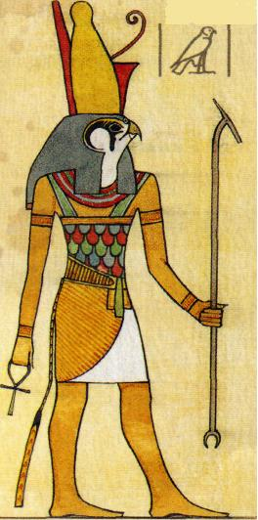
God and Goddesses Activity

Create an imaginary ancient Egyptian god/goddess. Empower your deity with two mystical powers. Each god must be illustrated with part animal and part human characteristics. As well, your god/goddess must use its powers to serve a purpose in ancient Egypt.

i.e. God of fitness= head of a fox with the body of a wrestler

When describing your gods/goddesses powers, you may describe it through story format.


