Ancient Mesopotamian Writing: Cuneiform
What?
• Developed since the Neolithic age, writing evolved from simple pictograms.
• Sumerians developed the pictogram system into a system of symbols, called cuneiform. These symbols were made up a series of straight lines, and were easier to write than pictograms.
• Originally, every symbol stood for a word. This system was later changed in favour of having every symbol stand for a syllable.
Key Definitions / Terms
• Pictogram - pictures that represent ideas, words or concepts.
• Cuneiform - wedge-shaped. Sumerian writing is described as wedge-shaped due to the triangular wedges which form the symbols.
Historical Significance
• The development of writing came about as a way of keeping track of inventory, but evolved into a way of communicating with other people effectively.
• Writing allowed for an easier transfer of ideas and information between people, greatly facilitating the progression of civilisation.
Interesting Facts
• Writing was first developed to keep track of a person's goods for accounting purposes.
• Later on, cuneiform was used for such purposes as recording daily events, and writing stories or personal letters.
• Sumerian cuneiform was later used by the Akkadians, Assyrians and Babylonians.
• The writing system developed by the Sumerians was also the first internationally used writing system - the Persians and Egyptians adapted it. Later on, other civilizations in the Middle East adapted cuneiform as well.
• There are over 600 cuneiform symbols.

Sample of Sumerian Cuneiform A Clay Tablet with Cuneiform

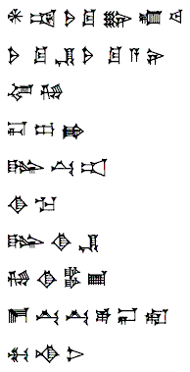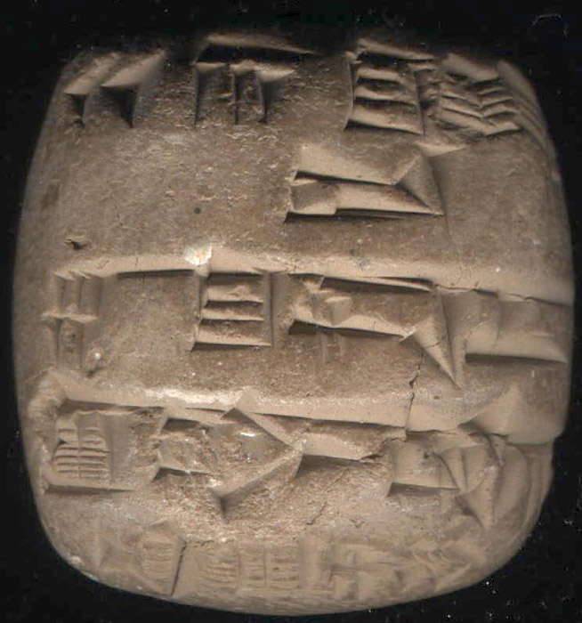
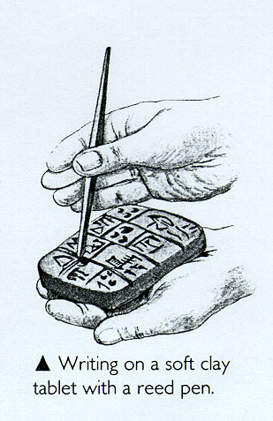 Illustration of how Sumerians wrote using cuneiform
Links
Related Links:
• About Cuneiform Writing
• Write Like a Babylonian
• The Origins of Writing in Mesopotamia
Related Articles:
• Sumerian Dictionary to Decipher Ancient Texts
• Sumerian Language
Bibliography:
Anderson, Sean., and Marc Levoy. The Stanford Cuneiform Tablet Visualization Project. 19 Feb. 2006. 13 Sep. 2006 <http://graphics.stanford.edu/projects/cuneiform/>.
Beck, Susan E. A Brief History of Information. 30 Aug. 1998. 15 Sep. 2006 <http://lib.nmsu.edu/instruction/lsc311/beck/03notes.html>.
Language Museum. Language Museum - Sumerian (Cuneiform). 14 Sep. 2006 <http://www.language-museum.com/s/sumerian-cuneiform.htm>.
Newman, Garfield. Echoes from the Past: World History to the 16th Century. Toronto: McGraw-Hill Ryerson Limited, 2001.
The British Museum. Writing - Mesopotamia. 13 Sep. 2006 <http://www.mesopotamia.co.uk/writing/home_set.html>.
The History Channel - A&E Television. Encyclopedia - Cuneiform. 14 Sep. 2006 <http://www.history.com/encyclopedia.do?articleId=206894>.

