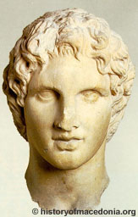
Alexander the Great
- Alexander III the Great, the King of Macedonia and conqueror of the Persian Empire, is considered one of the greatest military geniuses of all times.

- Alexander was born in 356 BC in Pella, the ancient capital of Macedonia. He was son of Philip II, King of Macedonia, and Olympias, the princess of neighboring Epirus. He spent his childhood watching his father transforming Macedonia into a great military power.

- When he was 13, Philip hired the Greek philosopher Aristotle to be Alexander’s personal tutor. During the next three years Aristotle gave Alexander training in rhetoric and literature and stimulated his interest in science, medicine, and philosophy.

- In 340, Philip assembled a large Macedonian army and invaded Thrace. Philip left his 16 year old son with the power to rule Macedonia in his absence as regent. However, as Philip’s Macedonian army advanced deep into Thrace, a Thracian tribe, Maedi, which bordered north-eastern Macedonia rebelled and posed a direct threat to Macedonia. Alexander assembled an army, led it against the rebels, and with swift action defeated the Maedi, captured their stronghold, and renamed it after himself to Alexandropolis.

- Two years later in 338 BC, Philip gave his son a commanding post among the senior generals as the Macedonian army invaded Greece. Alexander displayed his bravery by destroying the elite Greek force.

- Not too long after the defeat of the Greeks, the royal family split apart when Philip married Cleopatra, a Macedonian girl of high nobility. Alexander took his mother and fled the country.

- In the spring of 336 BC, with Philip’s Persian invasion already set in motion, the king was assassinated by a young Macedonian noble Pausanias. There is a claim that Pausanias was driven into committing the murder because he was denied justice by the king. There are also reports that that both Olympias and Alexander were responsible for the assassination, by driving the young men into committing the act.

- Philip, the great Macedonian conqueror was dead. His dream of conquering the Persian Empire now lays on his successor, his son king Alexander.

- Once he ascended on the Macedonian throne, Alexander quickly disposed of all of his domestic enemies by ordering their execution. He conquered northern Greece first then turned his sights on southern Greece. He then focused his attention on the Persian Empire and Asia. Over the next 13 years, (336BC to 323 BC) Alexander’s Army conquered much of the known world.

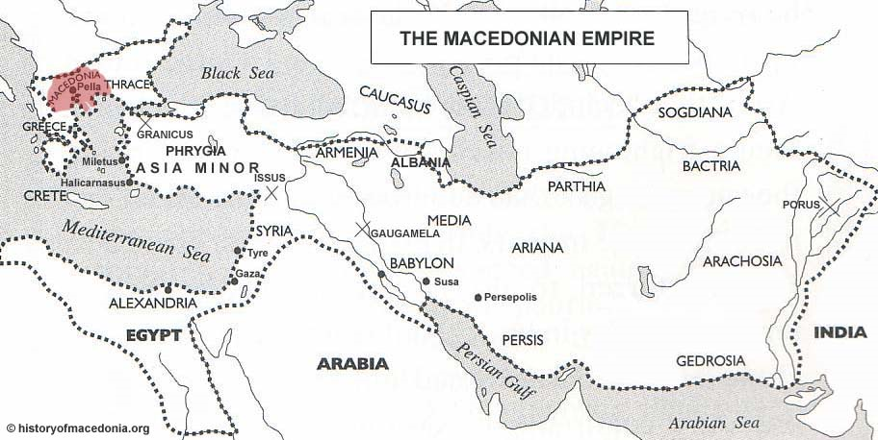

- Alexander the Great, the Macedonian king and the great conqueror of Persian Empire, died at the age of 33 without designating a successor to the Macedonian Empire.

